**Intelligent Data Analytics**

**Abhishek Kumar Gupta**

**ggplot (R) Visualizations**

**# Example 1**

library(tidyverse)

data(mpg)

**#1.(a, 3.2.4 Exercises#4)**

Make a scatterplot of hwy vs cyl

ggplot(data = mpg)+ geom_point(mapping = aes(x=cyl, y=hwy))

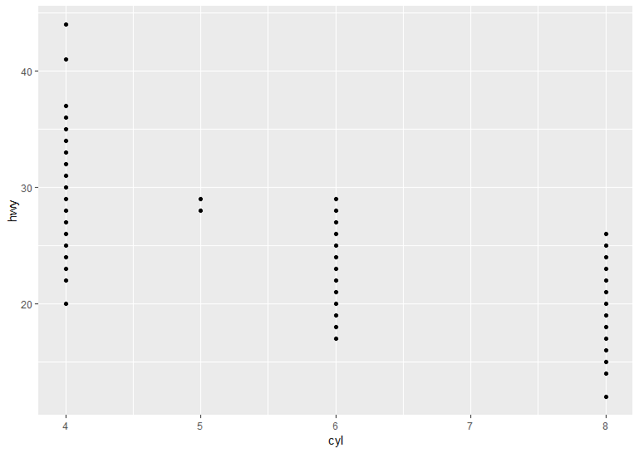

**#1.(a, 3.2.4 #5)**

What happens if you make a scatterplot of class vs drv ?

#Why is the plot not useful?

ggplot(data = mpg)+ geom_point(mapping = aes( x=drv, y=class))

# The plot is not much useful because there is not any trend in the plot and nothing can be concluded out of the plot.

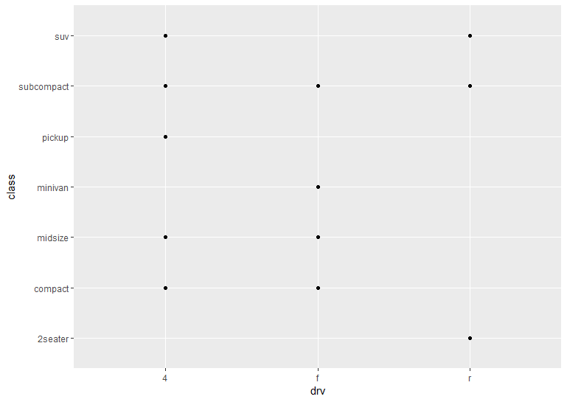

**#1.(a, 3.3.1 Exercises#3)**

Map a continuous & categorical variable to color, size and shape

#continuous variable map to color

ggplot(data = mpg)+

geom_point(mapping = aes(x=displ, y=hwy, color=cty))

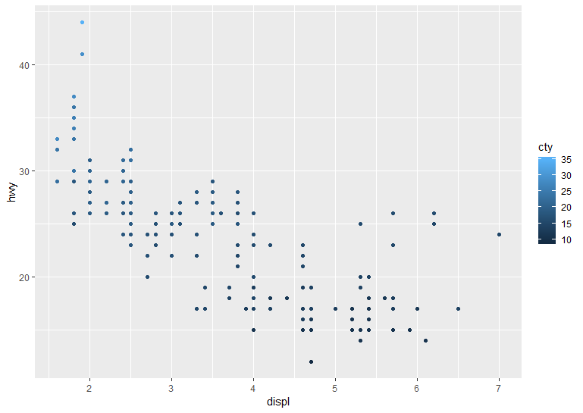

#continuous variable map to size

ggplot(data = mpg)+

geom_point(mapping = aes(x=displ, y=hwy, size=cty))

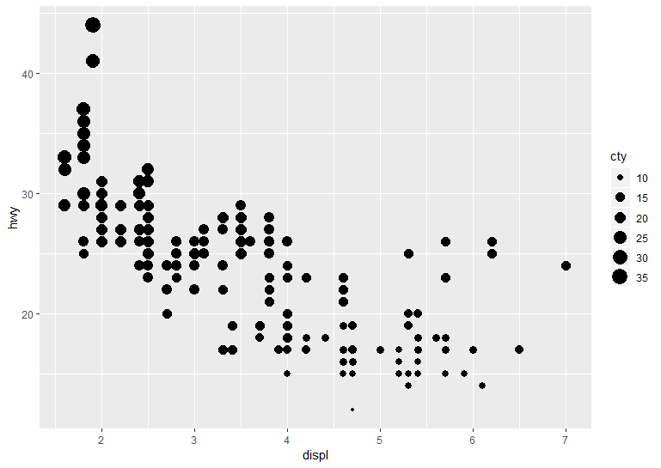

#continuous variable map to shape

ggplot(data = mpg)+

geom_point(mapping = aes(x=displ, y=hwy, shape=cty))

#categorical variable map to color

ggplot(data = mpg)+

geom_point(mapping = aes(x=displ, y=hwy, color=class))

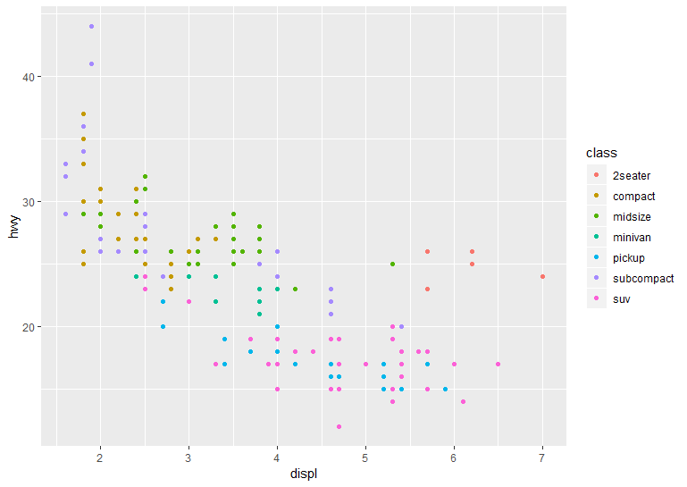

#categorical variable map to size

ggplot(data = mpg)+

geom_point(mapping = aes(x=displ, y=hwy, size=class))

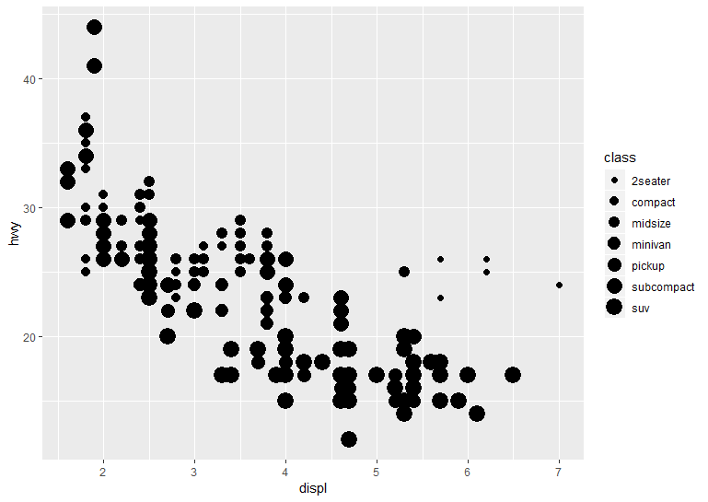

#categorical varible map to shape

ggplot(data = mpg)+

geom_point(mapping = aes(x=displ, y=hwy, shape=class))

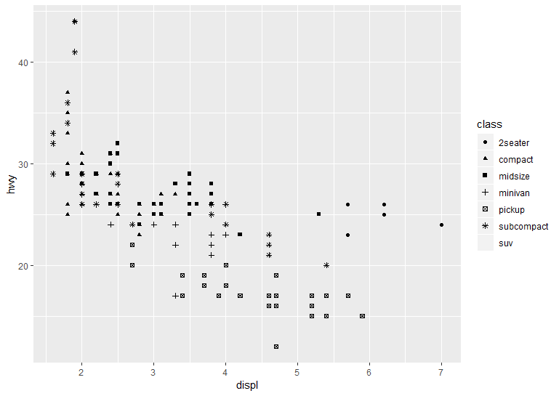

**#1.(a, 3.3.1 Exercises#4)**

What happens if you map the same variable to multiple aesthetics?

ggplot(data = mpg)+

geom_point(mapping = aes(x=displ, y=hwy, color=class, size=class, shape=class))

#We get a more refined plot where each feature is distinctly shown by different aesthetics

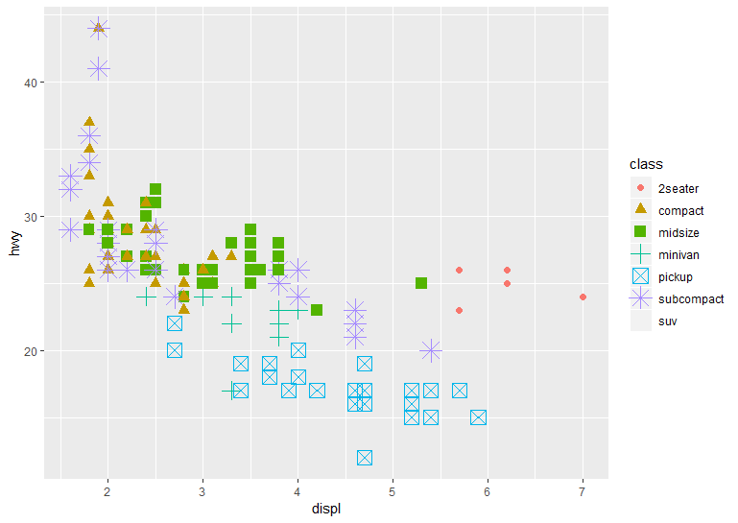

**# 1.(a, 3.3.1 Exercises#6).**

What happens if you map an aesthetic to something other than a variable name, like aes(colour = displ < 5) ?

ggplot(data = mpg)+

geom_point(mapping = aes(x=displ, y=hwy, color=displ<5))

# here it shows different color for values which are true i.e <5 and different for >5

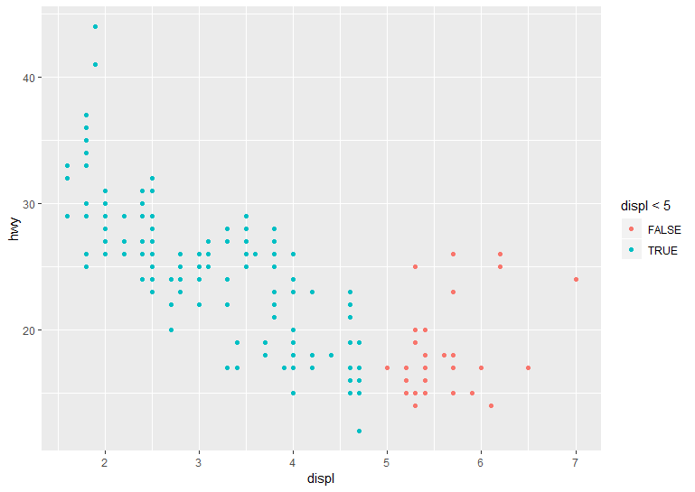

**# 1.(a, 3.5.1 Exercises#4)**

What are the advantages to using faceting instead of the colour aesthetic?

#What are the disadvantages?

#How might the balance change if you had a larger dataset?

ggplot(data = mpg) +

geom_point(mapping = aes(x = displ, y = hwy)) + facet_wrap(~ class, nrow = 2)

**Answer:**

The faceted plot gives the plot of two variables for each of the third variable. Its main advantage is that it gives the glimpse of the correlation between two parameters across all the third category. However, color schemes od the same thing but faceted gives more clear picture compared to color for small data set.

**Disadvantages:** As the dataset of the third variable increase, the number of plots will increase and it will become difficult to visualize of get the clear picture out of those plots.

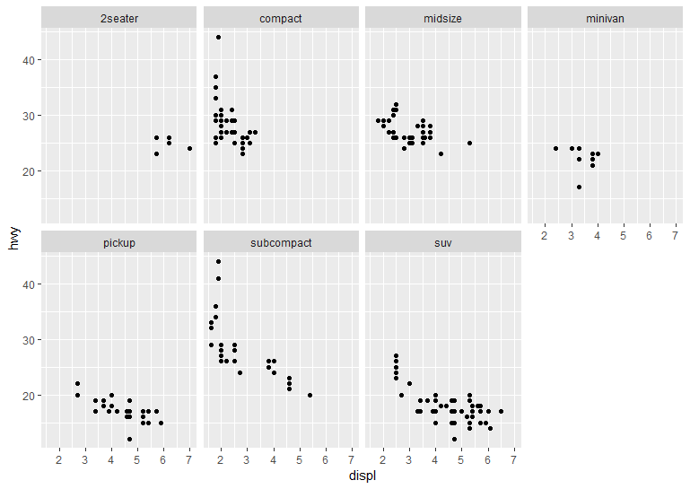

**#1(b)**

After reading this chapter, you should be ready to reproduce the plot in Figure 1

#using the same mpg data from above. Please do so.

p<-ggplot(data = mpg) +

geom_point(mapping = aes(x=displ, y=hwy, alpha=cty), position = "jitter") +

geom_smooth(mapping = aes(x = displ, y = hwy),method=lm,color="black", se=FALSE)+

geom_smooth(mapping = aes(x = displ, y = hwy))+

facet_wrap(~drv)

p+labs(x="Displacement", y="Highway Mpg")

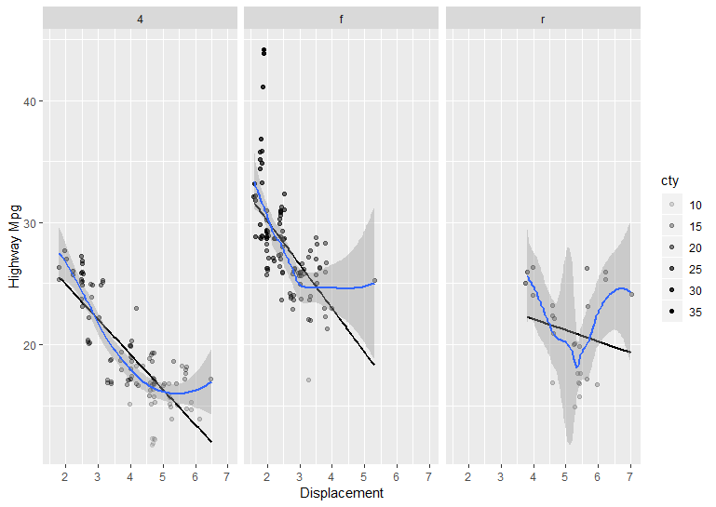

**#** **Example 2(a.)**

I have used random normal distribution, random poison distribution, random binomial distribution and random chi square distribution. gather function used to join all the four variables.

df<- data.frame(a=rnorm(500),b=rpois(500, lambda=3),c=rbinom(500,20,0.5),d=rchisq(500, df=3))

head(df)

a b c d

1 0.88591702 2 10 4.2808489

2 1.51094657 4 8 5.1385624

3 0.05073460 4 8 6.4322059

4 -0.02881551 2 7 1.2478455

5 -0.80646961 0 14 0.3320644

6 0.73189364 5 13 0.5103549

library(dplyr)

df2<-gather(df,key="groupVar", value="value")

head(df2)

groupVar value

1 a 0.88591702

2 a 1.51094657

3 a 0.05073460

4 a -0.02881551

5 a -0.80646961

6 a 0.73189364

**#** **Example 2(b.)**

Plot the densities of each distribution overlaid on each other on one plot

library(ggplot2)

ggplot(df2,mapping= aes(fill = groupVar, x=value))+ geom_density(alpha=0.4)

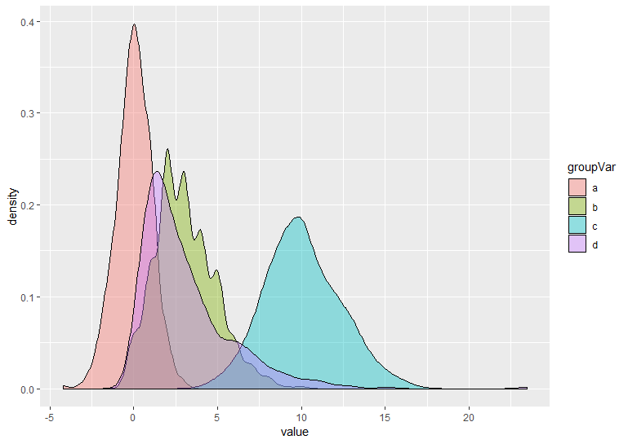

**#** **Example -3**

Housing proce data visualization

#read the CSV file form the working folder

myData<-read.csv("housingData.csv")

# scatter plot of sale price vs. lot area with housestyle as a color mapping

ggplot(data = myData)+

geom_point(mapping = aes(x=LotArea, y=SalePrice, color=HouseStyle))

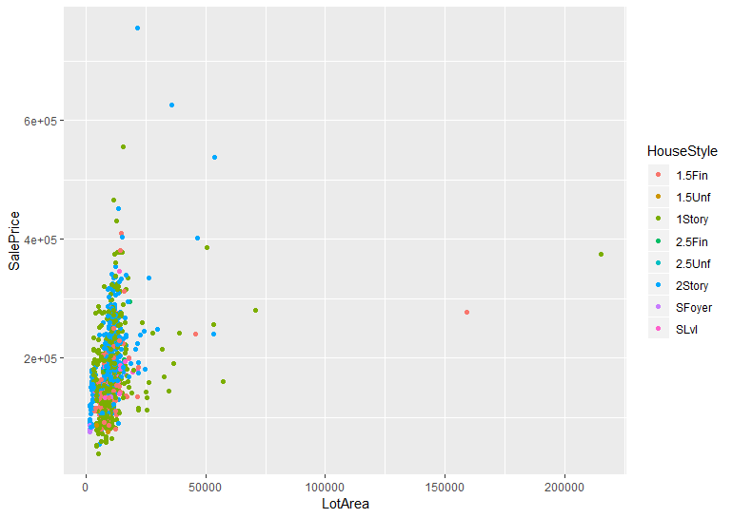

# bar grap plot of neoghborhood with fill of MSZoning

ggplot(data = myData, mapping = aes(x=Neighborhood, fill=MSZoning))+

geom_bar(alpha=0.5)

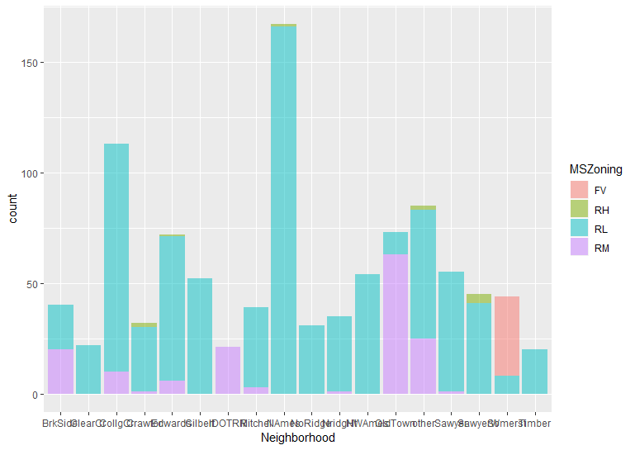

# bar grap plot of neoghborhood with fill of lotshape and dodge aesthetic

ggplot(data = myData, mapping = aes(x=Neighborhood, fill=LotShape))+

geom_bar(alpha=0.5, position = "dodge")

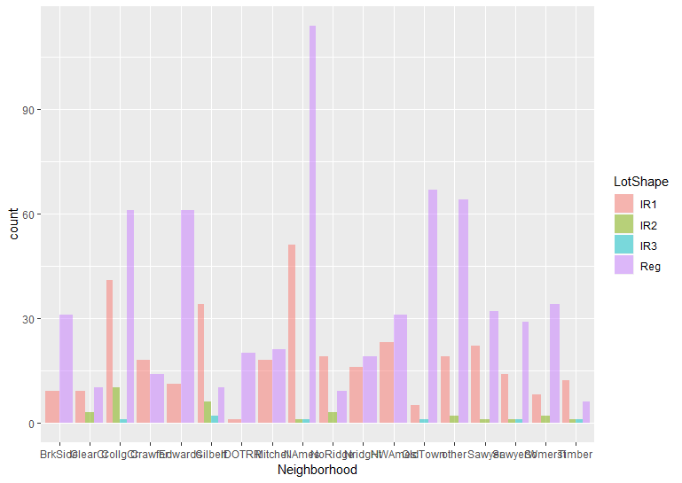

# box plot of condition1 with saleprice

ggplot(data = myData, mapping = aes(x=Condition1, y=SalePrice))+

geom_boxplot()

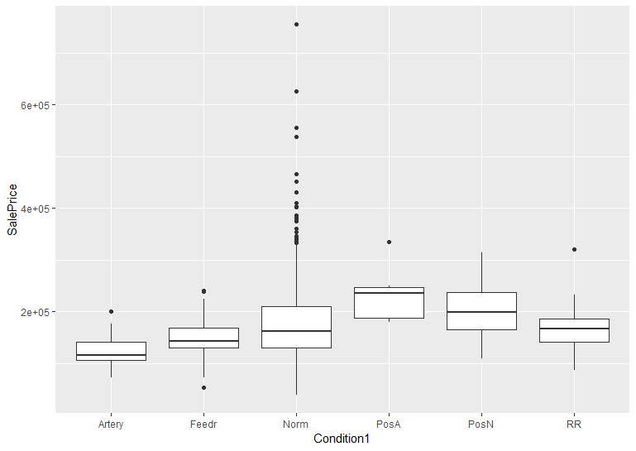

# bar grap plot of overall quality with fill of external qualtity along with plot in polar coordinates

bar<- ggplot(data=myData)+

geom_bar(mapping=aes(x=OverallQual, fill=ExterQual))

bar

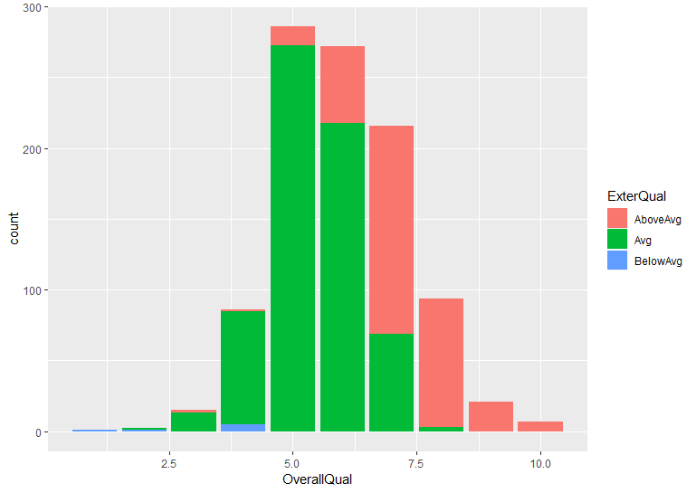

bar+coord_polar()

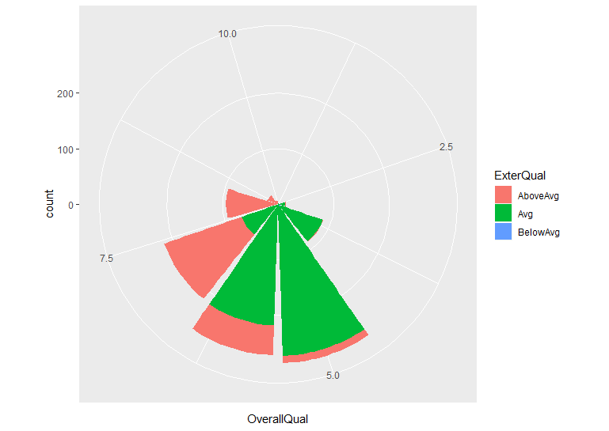

**#** **Example 4: Missing Data Handling**

**#(4a.)**

Explore the missingness of the data

#load the library Amelia and data freetrade

library(Amelia)

data(freetrade)

#load package mice for missingness analysis

install.packages("mice")

library(mice)

# gives the number of observation per variable pair

md.pairs(freetrade)

> md.pairs(freetrade)

$`rr`

year country tariff polity pop gdp.pc intresmi signed fiveop usheg

year 171 171 113 169 171 171 158 168 153 171

country 171 171 113 169 171 171 158 168 153 171

tariff 113 113 113 111 113 113 104 112 99 113

polity 169 169 111 169 169 169 156 166 151 169

pop 171 171 113 169 171 171 158 168 153 171

gdp.pc 171 171 113 169 171 171 158 168 153 171

intresmi 158 158 104 156 158 158 158 155 153 158

signed 168 168 112 166 168 168 155 168 150 168

fiveop 153 153 99 151 153 153 153 150 153 153

usheg 171 171 113 169 171 171 158 168 153 171

$rm

year country tariff polity pop gdp.pc intresmi signed fiveop usheg

year 0 0 58 2 0 0 13 3 18 0

country 0 0 58 2 0 0 13 3 18 0

tariff 0 0 0 2 0 0 9 1 14 0

polity 0 0 58 0 0 0 13 3 18 0

pop 0 0 58 2 0 0 13 3 18 0

gdp.pc 0 0 58 2 0 0 13 3 18 0

intresmi 0 0 54 2 0 0 0 3 5 0

signed 0 0 56 2 0 0 13 0 18 0

fiveop 0 0 54 2 0 0 0 3 0 0

usheg 0 0 58 2 0 0 13 3 18 0

$mr

year country tariff polity pop gdp.pc intresmi signed fiveop usheg

year 0 0 0 0 0 0 0 0 0 0

country 0 0 0 0 0 0 0 0 0 0

tariff 58 58 0 58 58 58 54 56 54 58

polity 2 2 2 0 2 2 2 2 2 2

pop 0 0 0 0 0 0 0 0 0 0

gdp.pc 0 0 0 0 0 0 0 0 0 0

intresmi 13 13 9 13 13 13 0 13 0 13

signed 3 3 1 3 3 3 3 0 3 3

fiveop 18 18 14 18 18 18 5 18 0 18

usheg 0 0 0 0 0 0 0 0 0 0

$mm

year country tariff polity pop gdp.pc intresmi signed fiveop usheg

year 0 0 0 0 0 0 0 0 0 0

country 0 0 0 0 0 0 0 0 0 0

tariff 0 0 58 0 0 0 4 2 4 0

polity 0 0 0 2 0 0 0 0 0 0

pop 0 0 0 0 0 0 0 0 0 0

gdp.pc 0 0 0 0 0 0 0 0 0 0

intresmi 0 0 4 0 0 0 13 0 13 0

signed 0 0 2 0 0 0 0 3 0 0

fiveop 0 0 4 0 0 0 13 0 18 0

usheg 0 0 0 0 0 0 0 0 0 0

# display missing data pattern

md.pattern(freetrade)

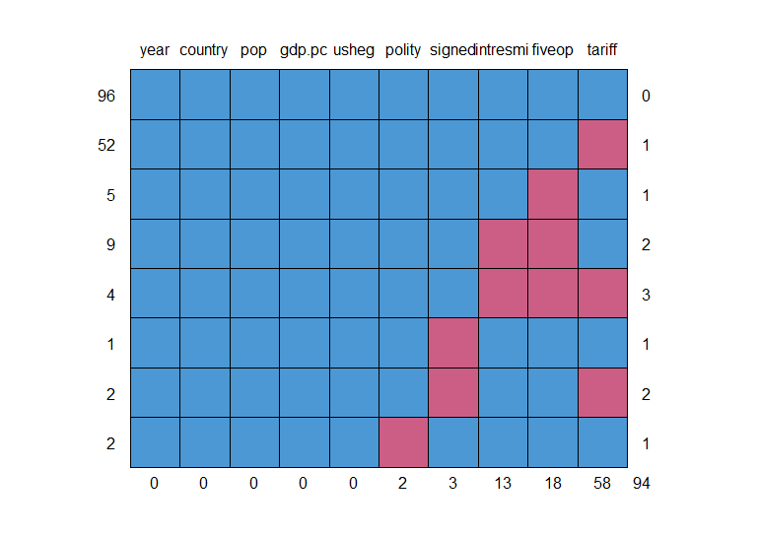

#load package VIM for missingness analysis

library(VIM)

#used VIM's "aggr" function to also get overall information on missing

a<-aggr(freetrade)

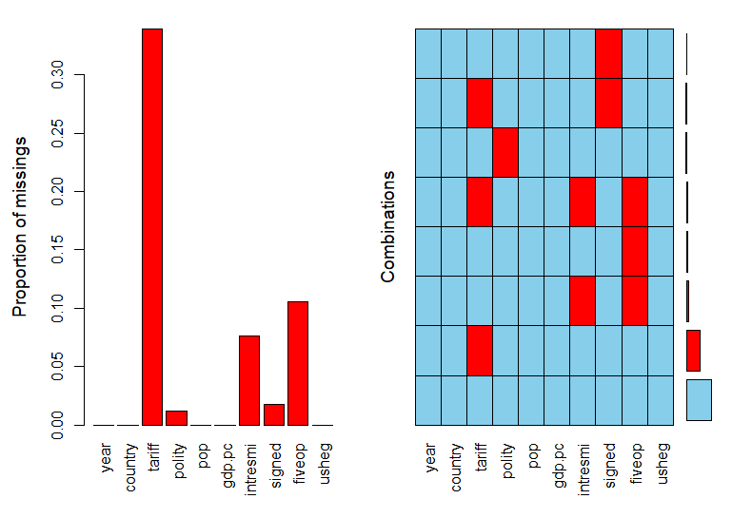

summary(a)

> #used VIM's "aggr" function to also get overall information on missing

> a<-aggr(freetrade)

> summary(a)

Missings per variable:

Variable Count

year 0

country 0

tariff 58

polity 2

pop 0

gdp.pc 0

intresmi 13

signed 3

fiveop 18

usheg 0

Missings in combinations of variables:

Combinations Count Percent

0:0:0:0:0:0:0:0:0:0 96 56.1403509

0:0:0:0:0:0:0:0:1:0 5 2.9239766

0:0:0:0:0:0:0:1:0:0 1 0.5847953

0:0:0:0:0:0:1:0:1:0 9 5.2631579

0:0:0:1:0:0:0:0:0:0 2 1.1695906

0:0:1:0:0:0:0:0:0:0 52 30.4093567

0:0:1:0:0:0:0:1:0:0 2 1.1695906

0:0:1:0:0:0:1:0:1:0 4 2.3391813

# use VIM function "marginplot" to get a scatter plot that includes information on missing values

marginplot(freetrade[c("tariff","fiveop")], col=c("blue","red","orange"))

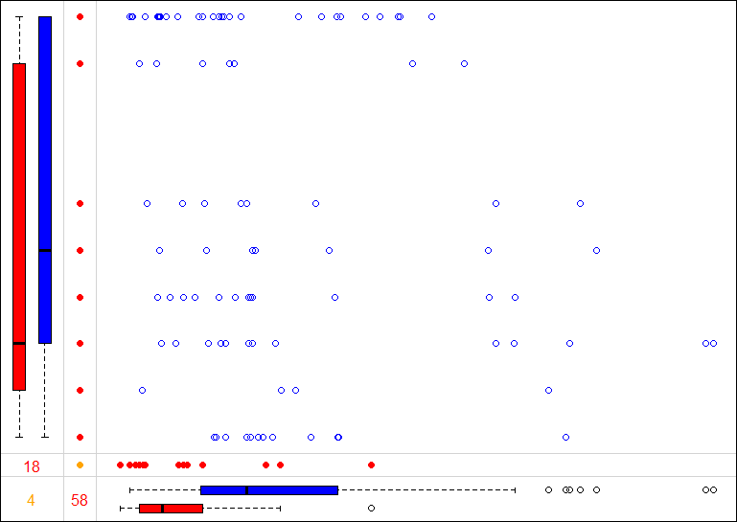

#looking at all of the plots with Missing Information

scattmatrixMiss(freetrade)

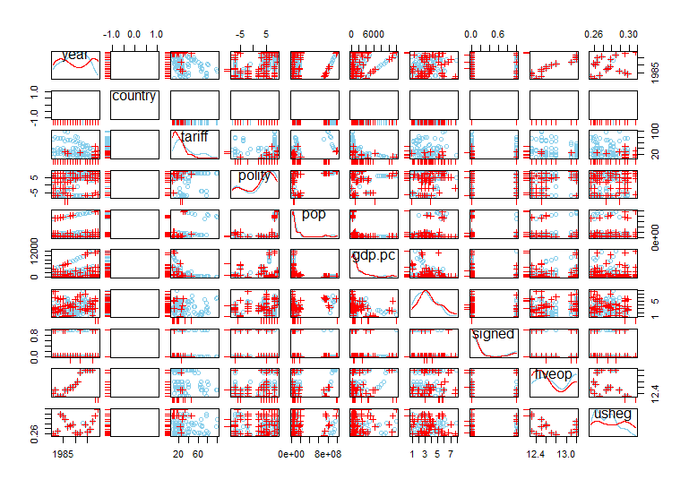

**#(4b.)**

statistical test chi-square used to determine if the missingness in the

#tariff variable is independent with the country variable

chisq.test(freetrade$tariff,freetrade$country)

Pearson's Chi-squared test

data: freetrade$tariff and freetrade$country

X-squared = 831.96, df = 736, **p-value = 0.007819**

Since, p value is almost zero, we reject the null that the missingness of tariff is independent of county. So, they are dependent. It becomes clear when we remove Nepal and Phillipines, we see change in p-value.

**#removed Nepal** from the data and again prformed Chisq test

freetrade=freetrade[which(freetrade$country!="Nepal"), ]

chisq.test(freetrade$tariff,freetrade$country)

Pearson's Chi-squared test

data: freetrade$tariff and freetrade$country

X-squared = 831.96, df = 736, **p-value = 0.007819**

#removed Philippines from the data and again prformed Chisq test

library(Amelia)

data(freetrade)

freetrade=freetrade[which(freetrade$country!="Philippines"), ]

chisq.test(freetrade$tariff,freetrade$country)

Pearson's Chi-squared test

data: freetrade$tariff and freetrade$country

X-squared = 639.33, df = 574, **p-value = 0.03012**

Hence we see the missingness of tariff affects the p-value in the three cases. Initially, it was almost zero (0.007) indicating the dependence of both the parameter. When we remove Nepal p-value changes to (0.1) and when Philippines removed(p-value=0.03).